Chill at Home Zone
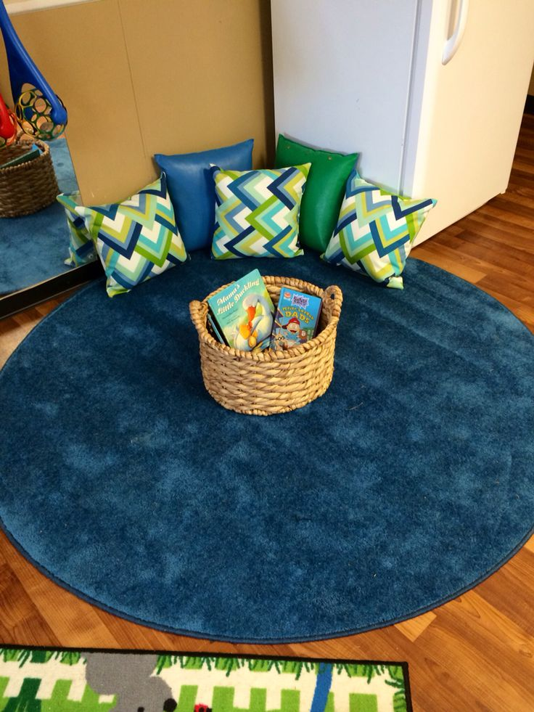

Purpose:
The ultimate goal is to be able to release the emotion that is blocking the learning—the students become the solution and are once again ready to learn.

When to use:
Any time your child appears frustrated or is starting to shut down with a learning activity. This provides a purposeful break to help get them back on track so they can finish their task.

What you will need:
*a quiet corner/space
*soft items (beanbag chair, pillow, sleeping bag, blankets, etc.)
*timer (set for 5 minutes)
*bin/box/basket for social-emotional learning tools
*tool suggestions: coloring book, maze book, word search, picture books, squishy items, stuffed animals, tactile items (clay), etch-a-sketch, doodle pad, puzzles, etc.

Rules and parameters for use:
*it is suggested that child ask for permission to attend chill zone with reason (example: I need to use the chill zone because I feel…)
*choose 1 tool from the SEL bin to use for chill zone session (it is not recommended that the child switch tools)
*set timer for 5 minutes (most of our students are ready to learn within that time frame, however needs may vary)
*once timer goes off- the child will put the tool back in the bin and assess whether they are ready to learn
*be consistent with these parameters so your child understands exact usage and purpose

